Day 27 — 4-Bit Carry Look-Ahead Adder Using Verilog HDL
Introduction: A Carry Look-Ahead Adder (CLA) is a high-speed combinational logic circuit used to perform binary addition. Unlike a Ripple Carry Adder, the CLA calculates the carry signals in advance using Generate and Propagate signals. This reduces the carry propagation delay and improves the speed of addition.
Design of Carry Look-Ahead Adder: The 4-bit CLA takes two 4-bit inputs A and B along with an input carry C_IN. The circuit generates a 4-bit RESULT and C_OUT. The carry signals are calculated using Generate and Propagate logic.
Generate and Propagate:n Gi​=Ai​Bi​ Pi​=Ai​⊕Bi​
Carry Equations:
C0​=CIN​
C1​=G0​+P0​C0​
C2​=G1​+P1​G0​+P1​P0​C0
​ C3​=G2​+P2​G1​+P2​P1​G0​+P2​P1​P0​C0​
C4​=G3​+P3​G2​+P3​P2​G1​+P3​P2​P1​G0​+P3​P2​P1​P0​C0​
COUT​=C4​
RESULT Equation: i​=Pi​⊕Ci​
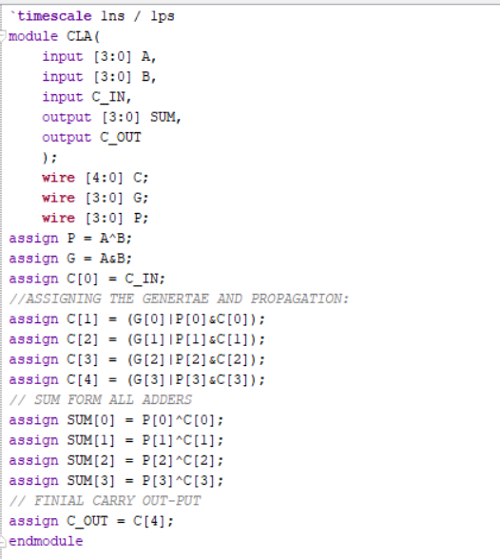
Testbench: A testbench was created to verify the operation of the 4-bit Carry Look-Ahead Adder. Different combinations of 4-bit values were applied to A, B, and C_IN. The RESULT and C_OUT outputs were observed and compared with the expected results.
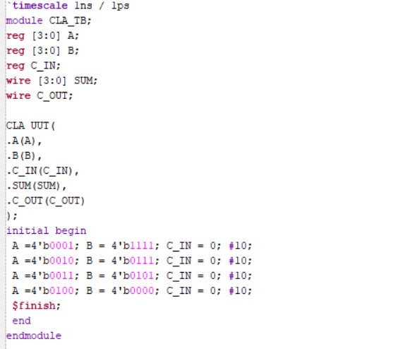
Waveform: The simulation waveform was used to verify the operation of the Carry Look-Ahead Adder. The following signals were observed:
The waveform verifies that the CLA produces the correct addition results and carry output.
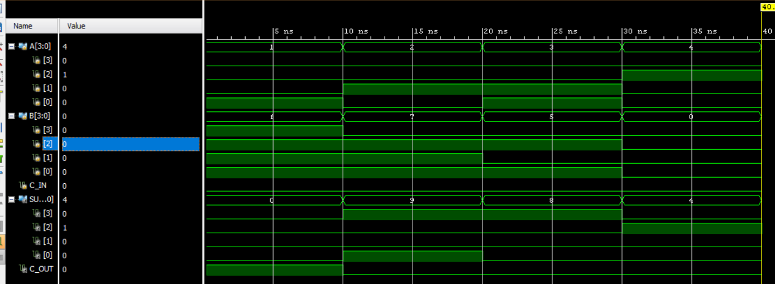

Schematic: The RTL schematic shows the Generate, Propagate, Look-Ahead Carry Logic, and Sum logic used to implement the 4-bit CLA.
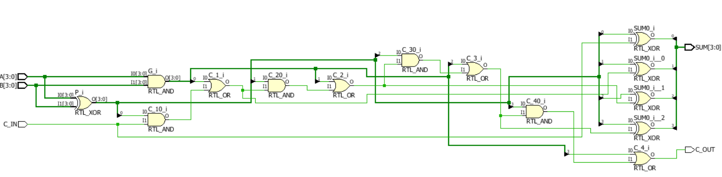
Observation: The 4-bit Carry Look-Ahead Adder was successfully designed and verified. The CLA calculates carry signals in advance using Generate and Propagate logic, reducing carry propagation delay compared to a Ripple Carry Adder.

#PHANEENDRA.SINGUDASU

